

**DBMS MINI PROJECT**

NSS MANAGEMENT SYSTEM

**Team no:** 2

**Member 1:** NIKAASH T K (2022103035)

**Member 2:** ANAND KARTHIKEYAN S (2022103305) **Degree:** B.E CSE

**Semester:** 4

**Batch:** P

**Subject code:** CS6106

**Subject name:** Database Management Systems **Submitted on:** 23/05/2024

**Submitted to:** Dr.S.Renugadevi, Department of Computer Science and Engineering, CEG, Anna University.

**PROBLEM STATEMENT:**

To develop a comprehensive database management system for NSS units within a specific college (institution) to enhance organizational efficiency and foster community engagement.

**GENERAL INTRODUCTION:**

The National Service Scheme (NSS) is a student-centred program aimed at fostering social responsibility and community engagement among young individuals. Within educational institutions, NSS units play a crucial role in coordinating various social service activities and events. This project is a comprehensive database management system for managing the operations of NSS units within a specific college.

**PROJECT ABSTRACT:**

This project aims to streamline the management of NSS activities by designing and implementing a robust database system. The system will facilitate the management of records and details of the organization as well as efficient coordination of NSS activities. By providing a centralized platform for managing volunteer data and activities, the database system seeks to optimize resource allocation, improve communication, and strengthen the impact of NSS efforts within the college community.

The manual maintenance of records in an organization requires a lot of manual work and a lot of time. It is also difficult to maintain hard copies of records. Due to maintenance limitations tracking historical data is not possible beyond an extent. And the retrieval of data is also not very effective. Even when data is stored in file systems the retrieval methods are deliberate. And thus, using a database to store all the data related to an organization which is NSS is an outstanding and apt solution. In a database, it is possible to retrieve data easily and effectively, modifications can be done effortlessly, and we can keep track of old data in archive for future reference. A perfect user interface for this DBMS project makes all the functionalities easier and even more convenient.

This DBMS will facilitate efficient organization, coordination, and tracking of volunteer activities, events, and participation within NSS units. Key requirements include registration and management of volunteers, assignment and management of roles within NSS units, tracking of volunteer activities, events, and participation, managing program officers overseeing NSS units, and integrating active alumni into NSS activities and events.

**TECHNOLOGIES USED:**

**Frontend Technologies:** HTML, CSS, JavaScript, React.js

**Backend Technologies:** Node.js, Express.js,

**Database:** PostgreSQL *(cloud database provided by Neon)*

This web application is built by frontend and backend technologies which are used by most professional developers of this time. *(Source: StackOverflow Developer Survey 2023)*

**ENTITIES:**

1. Unit (Unit No, P.O. ID, General Secretory, Joint Secretory,                 No of Volunteers, Manuals conducted)

2. Volunteers (Volunteer ID, Unit No,Name,DOB, Gender, Email ID, Joining Date, Year of Study, Password)

3. Program Officers (P.O. ID, Name, Designation, Department, Email ID)

4. Alumni (Alumni ID, Name, Unit No, Year of Passing, Email ID)

5. Manuals (Manual ID, Unit No*,* Theme, Description, Date, Duration, Location, Lead Organizer ID)

**OTHER TABLES:**

1. Contact (Contact ID, Phone no) #multivalued attribute

2. Participations (VolunteerID, Manual ID) #relationship

3. Volunteer Roles (Volunteer ID, Role ID) #relationship

4. Admin (Admin ID, Name, Password) #Overall admin

5. Roles (Role ID, Role Title) #role reference

**CONSTRAINTS:**

**Foreign key constraints:**

1. Unit (Unit No) — >Volunteer (Unit No), Manuals (Unit No), Alumni (Unit No)

2. Volunteers (Volunteer ID) — > Participation (Volunteer ID), Volunteer Roles (Volunteer ID), Manuals (Lead Organizer ID)

3. Program Officers (P.O ID) — > Unit (P.O ID)

**Unique Constraints:**

1. Volunteer (Email ID)

 2. Program Officers (Email ID)

3. Alumni (Email ID)

4. Participations (VolunteerID, Manual ID)

5. Volunteer Roles (Volunteer ID, Role ID)

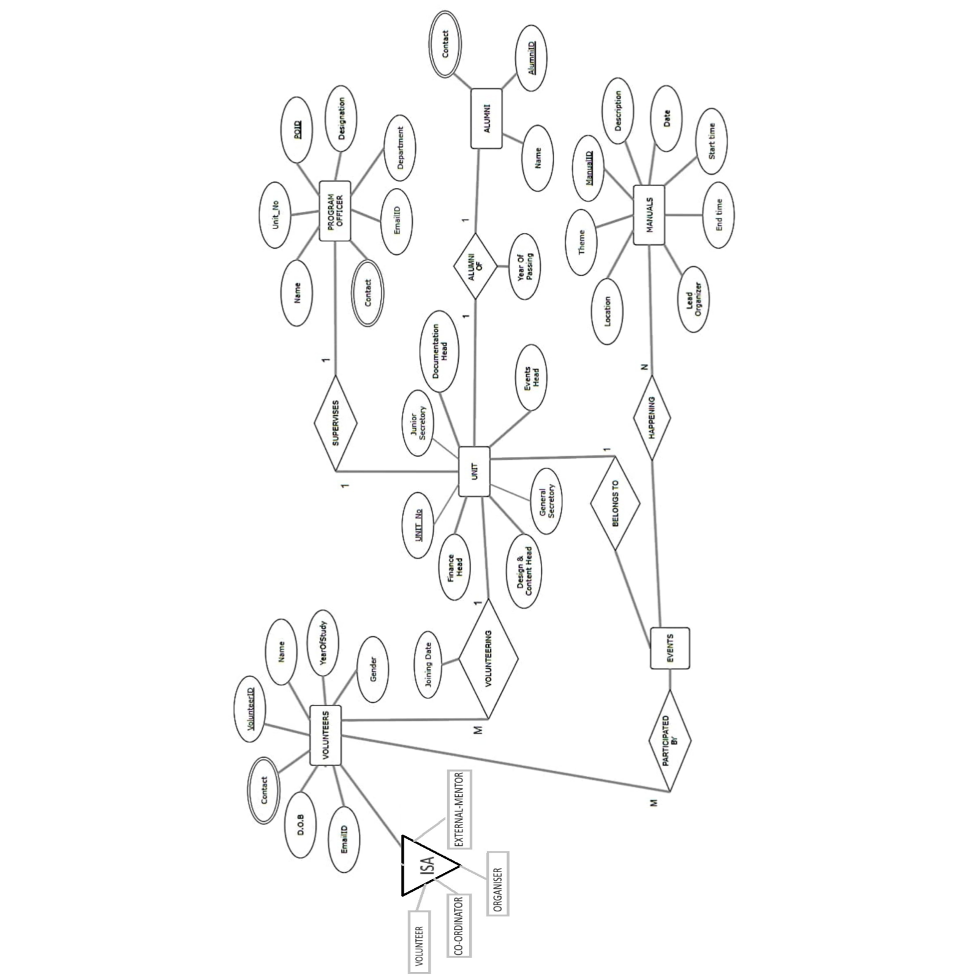**ER DIAGRAM:**

**RELATIONAL DATABASE MODEL:**

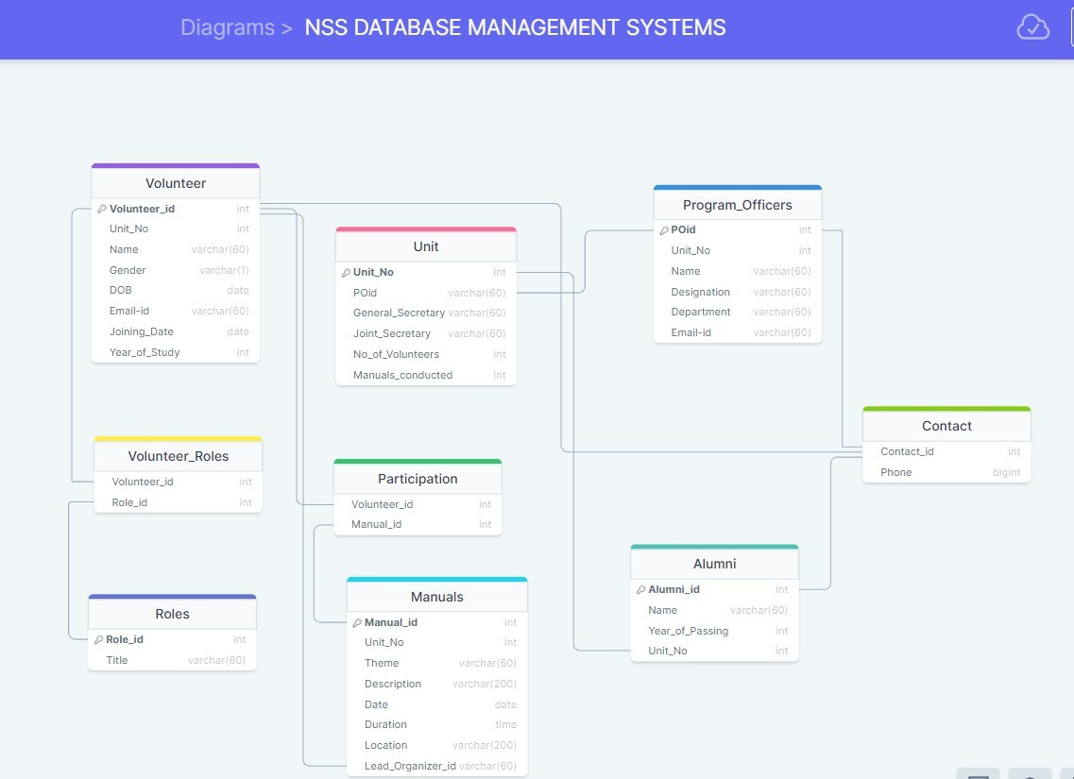

**DATABASE ORGANIZATION:**

**Functions:**

**1)** CREATE OR REPLACE FUNCTION move_to_alumni()

RETURNS TRIGGER AS $$

DECLARE

years_out INT;

BEGIN

years_out := EXTRACT(YEAR FROM CURRENT_DATE);

IF NEW."current_year" > 4 THEN

INSERT INTO alumni ("alumni_id", "year_of_passing", "name", "unit_no","email")

VALUES (NEW."volunteer_id", years_out, NEW."name", NEW."unit_no",NEW."email");

delete from volunteers where volunteer_id = new.volunteer_id;

END IF;

RETURN NULL;

END;

$$ LANGUAGE plpgsql;

**2)** CREATE OR REPLACE FUNCTION update_no_of_volunteers()

RETURNS TRIGGER AS $$

BEGIN

IF (TG_OP = 'INSERT') THEN

UPDATE unit SET no_of_volunteers = no_of_volunteers + 1 WHERE unit_no = NEW.unit_no;

ELSIF (TG_OP = 'DELETE') THEN

UPDATE unit SET no_of_volunteers = no_of_volunteers - 1 WHERE unit_no = OLD.unit_no;

ELSIF (TG_OP = 'UPDATE') THEN

IF (NEW.unit_no <> OLD.unit_no) THEN

UPDATE unit SET no_of_volunteers = no_of_volunteers + 1 WHERE unit_no = NEW.unit_no;

UPDATE unit SET no_of_volunteers = no_of_volunteers - 1 WHERE unit_no = OLD.unit_no;

END IF;

END IF;

RETURN NULL;

END;

$$ LANGUAGE plpgsql;

**3)** CREATE OR REPLACE FUNCTION assign_unit_no() RETURNS TRIGGER AS $$

DECLARE

max_unit_no_m INT;

max_unit_no_f INT;

new_volunteerid INT;

year_of_study INT;

year_dob INT;

BEGIN

SELECT unit_no INTO max_unit_no_m FROM volunteers WHERE volunteer_id = (SELECT MAX(volunteer_id) FROM volunteers WHERE gender = 'M');

SELECT unit_no INTO max_unit_no_f FROM volunteers WHERE volunteer_id = (SELECT MAX(volunteer_id) FROM volunteers WHERE gender = 'F');

SELECT MAX(volunteer_id) + 1 INTO new_volunteerid FROM volunteers;

IF NEW.gender = 'M' AND ((max_unit_no_m IS NULL) OR (max_unit_no_m = 3)) THEN

NEW.unit_no := 1;

ELSIF NEW.gender = 'M' THEN

NEW.unit_no := max_unit_no_m + 1;

ELSIF NEW.gender = 'F' AND ((max_unit_no_f) IS NULL OR (max_unit_no_f = 3)) THEN

NEW.unit_no := 1;

ELSIF NEW.gender = 'F' THEN

NEW.unit_no := max_unit_no_f + 1;

END IF;

NEW.joining_date := TO_CHAR(CURRENT_DATE, 'YYYY-MM-DD');

RETURN NEW;

END;

$$ LANGUAGE plpgsql;

**4)** CREATE OR REPLACE FUNCTION role_id()

RETURNS TRIGGER AS $$

begin

insert into volunteer_roles(volunteer_id,role_id) values (NEW.volunteer_id , 1);

RETURN NULL;

END;

$$ LANGUAGE plpgsql;

**5)** CREATE OR REPLACE FUNCTION volunteer_remove()

RETURNS TRIGGER AS $$

BEGIN

DELETE FROM volunteers where volunteer_id=NEW.alumni_id;

RETURN NULL;

END;

$$ LANGUAGE plpgsql;

**6)** CREATE OR REPLACE FUNCTION remove_roleid()

RETURNS TRIGGER AS $$

begin

delete from volunteer_roles where volunteer_id=old.volunteer_id;

delete from participations where volunteer_id=old.volunteer_id;

RETURN OLD;

END;

$$ LANGUAGE plpgsql;

**7)** CREATE OR REPLACE FUNCTION manualid_insert()

RETURNS TRIGGER AS $$

declare

t_mid int;

BEGIN

select max(manual_id)+1 into t_mid from manuals ;

NEW.manual_id := t_mid;

RETURN NEW;

END;

$$

LANGUAGE plpgsql;

**8)** CREATE OR REPLACE FUNCTION update_manuals_conducted()

RETURNS TRIGGER AS $$

BEGIN

UPDATE unit

SET manuals_conducted = manuals_conducted + 1

WHERE unit_no = NEW.unit_no;

RETURN NEW;

END;

$$

LANGUAGE plpgsql;

**9)** CREATE OR REPLACE FUNCTION manual_delete_after()

RETURNS TRIGGER AS $$

BEGIN

delete from participations where manual_id= OLD.manual_id;

update unit set manuals_conducted= manuals_conducted-1

where unit_no = ( select unit_no from manuals where manual_id = OLD.manual_id);

RETURN OLD;

END;

$$

LANGUAGE plpgsql;

**10)** CREATE OR REPLACE FUNCTION check_current_year_before_insert()

RETURNS TRIGGER AS $$

BEGIN

IF TG_OP = 'INSERT' AND NEW.current_year >= 5 THEN

RAISE EXCEPTION 'current_year must be less than 4 during insert';

END IF;

RETURN NEW;

END;

$$ LANGUAGE plpgsql;

**Triggers:**

**1)** CREATE or replace TRIGGER move_to_alumni

AFTER UPDATE ON volunteers

FOR EACH ROW

EXECUTE FUNCTION move_to_alumni();

**2)** CREATE or replace TRIGGER update_no_of_members_trigger

AFTER INSERT OR DELETE OR UPDATE ON volunteers

FOR EACH ROW

EXECUTE FUNCTION update_no_of_volunteers();

**3)** CREATE OR REPLACE TRIGGER assign_unit_no

BEFORE INSERT ON volunteers

FOR EACH ROW

EXECUTE FUNCTION assign_unit_no();

**4)** CREATE or replace TRIGGER role_id_insert

AFTER insert ON volunteers

FOR EACH ROW

EXECUTE FUNCTION role_id();

**5)** create or replace trigger volunteer_remove

after insert ON alumni

FOR EACH ROW

EXECUTE FUNCTION volunteer_remove();

**6)** CREATE or replace TRIGGER remove_roleid

before delete ON volunteers

FOR EACH ROW

EXECUTE FUNCTION remove_roleid();

**7)** CREATE OR replace TRIGGER manualid_insert

BEFORE INSERT ON manuals

FOR EACH ROW

EXECUTE FUNCTION manualid_insert();

**8)** CREATE OR replace TRIGGER update_manuals_conducted_trigger

AFTER INSERT ON manuals

FOR EACH ROW

EXECUTE FUNCTION update_manuals_conducted();

**9)** CREATE OR replace TRIGGER manual_delete_after

after delete ON manuals

FOR EACH ROW

EXECUTE FUNCTION manual_delete_after();

**10)** CREATE or replace TRIGGER check_current_year_trigger

BEFORE INSERT ON volunteers

FOR EACH ROW

EXECUTE FUNCTION check_current_year_before_insert();

**Cursor:**

**1)**

CREATE OR REPLACE FUNCTION fetch_manuals_for_unit(unit_no_param INT)

RETURNS SETOF manuals AS $$

DECLARE

manual_record manuals%ROWTYPE;

manual_cursor CURSOR FOR

SELECT * FROM manuals WHERE unit_no = unit_no_param ORDER BY manual_id ASC;

BEGIN

FOR manual_record IN manual_cursor LOOP

RETURN NEXT manual_record;

END LOOP;

RETURN;

END;

$$ LANGUAGE plpgsql;

SELECT * FROM fetch_manuals_for_unit(1);

**IMPLEMENTATION:**

**Home Page:**



**Register Page:**

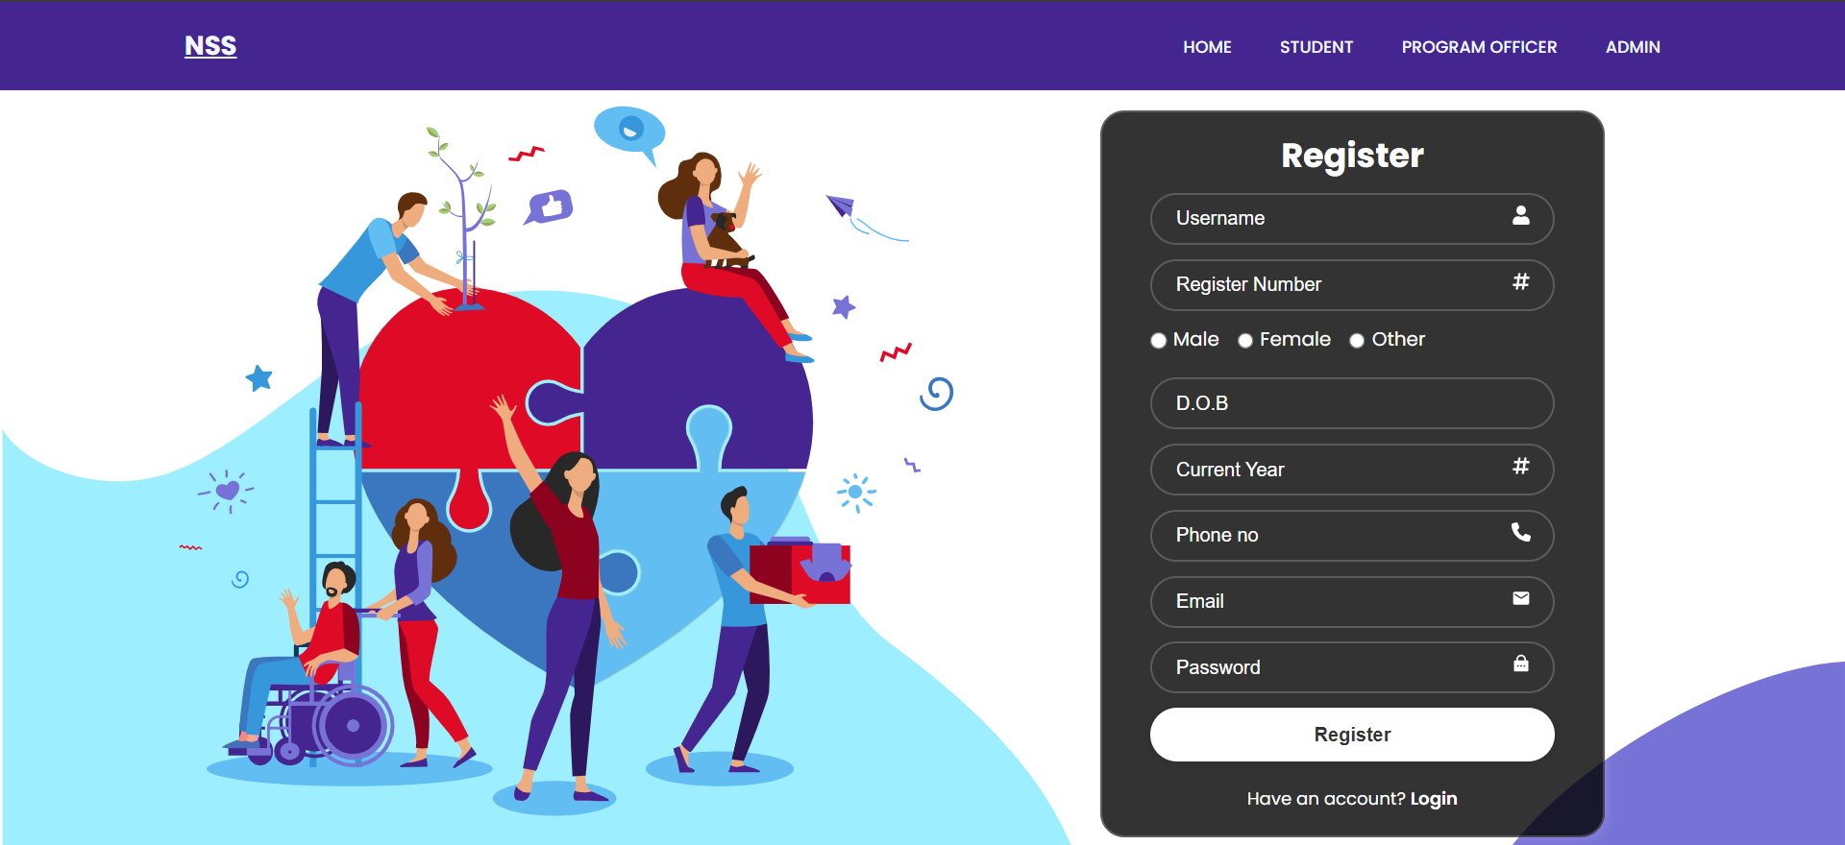

**Login Page:**

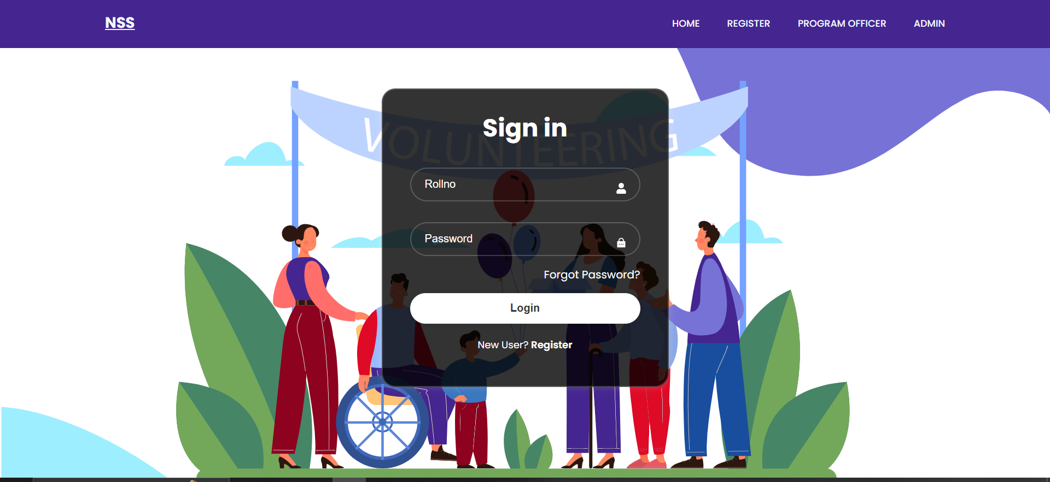

**Login Response Page:**

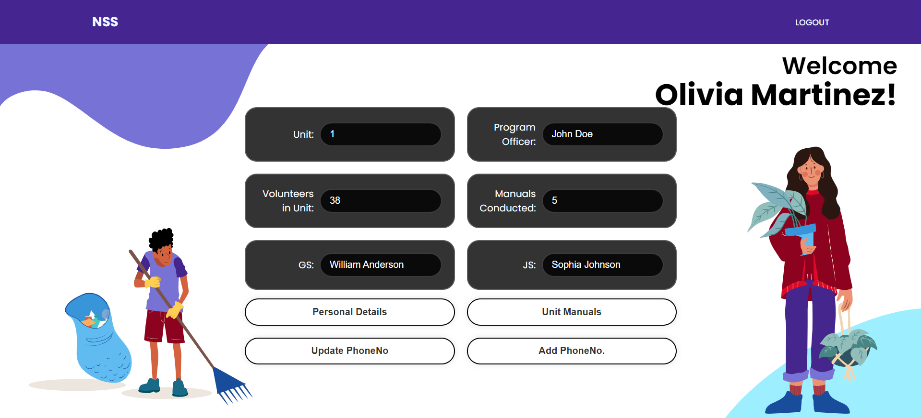

**Personal Details :**

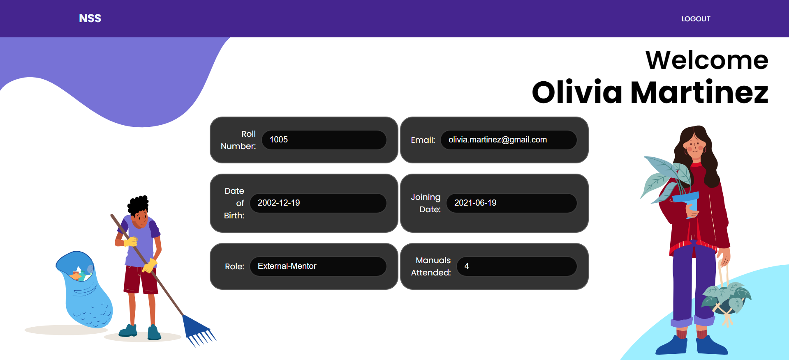

**Update/Add phone number :**

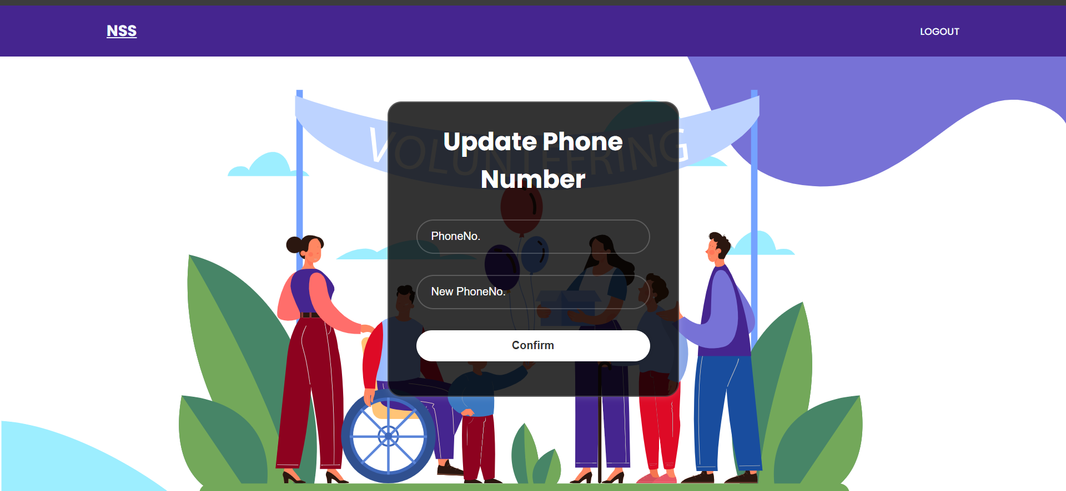

**Manual Details:**

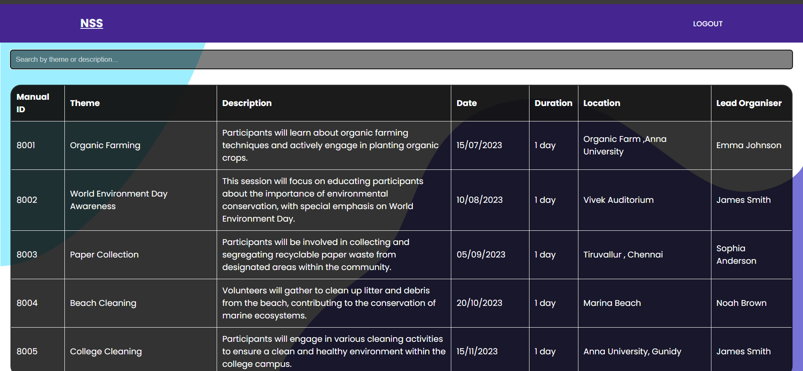

**PO Login Response :**

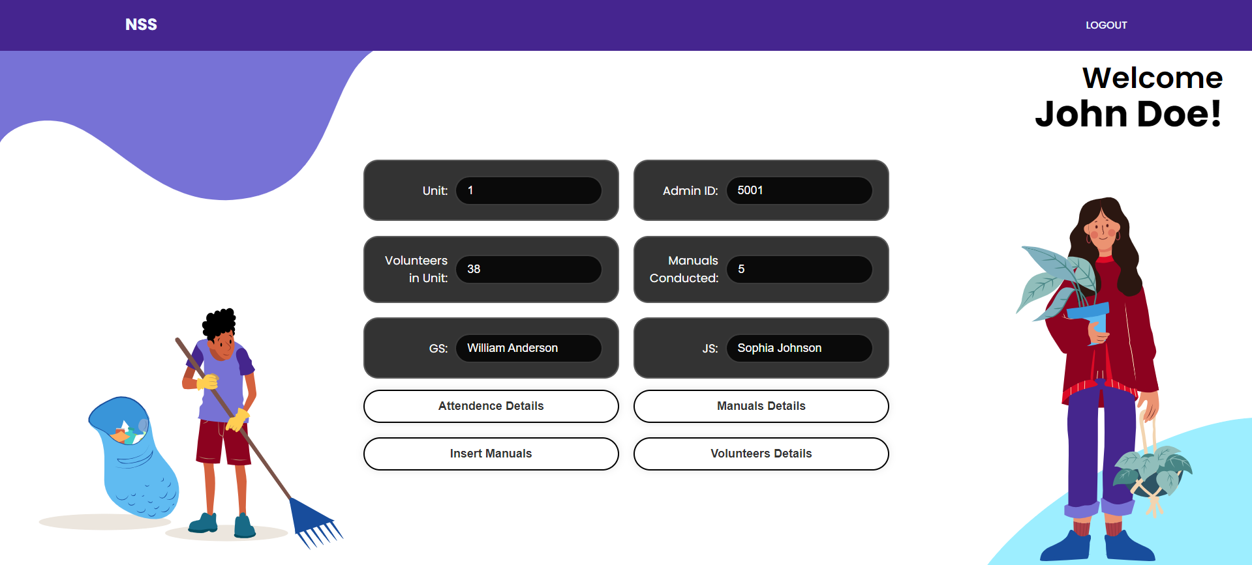

**Attendance Details:**

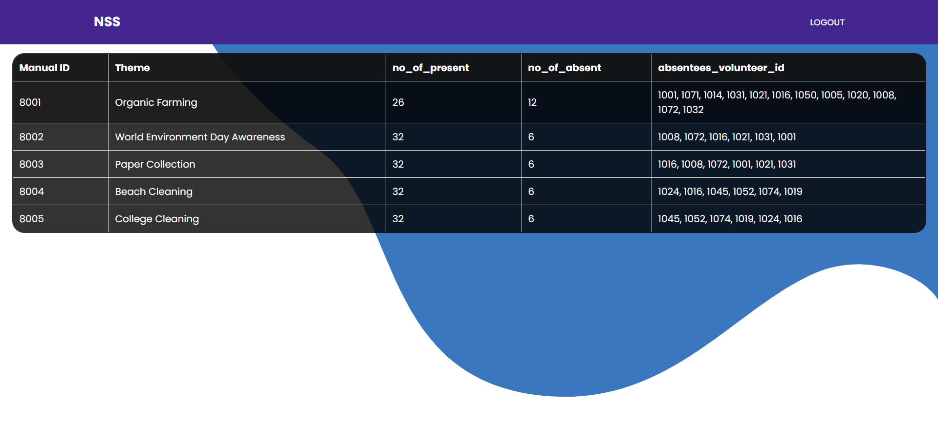

**Volunteers Details:**

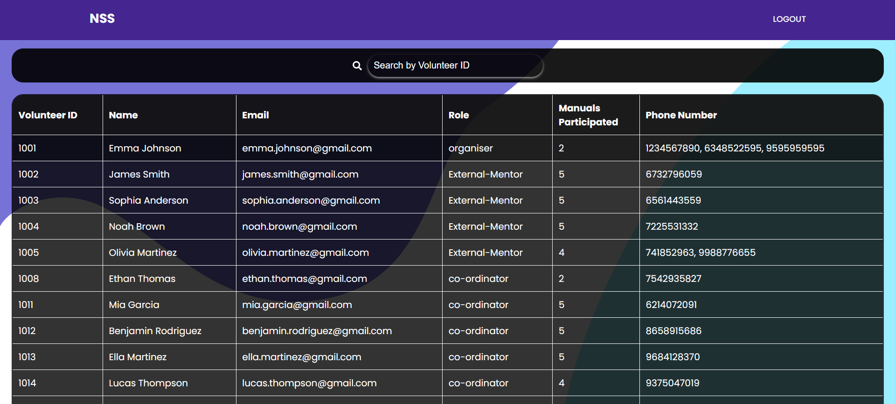

**Insert Manuals:**

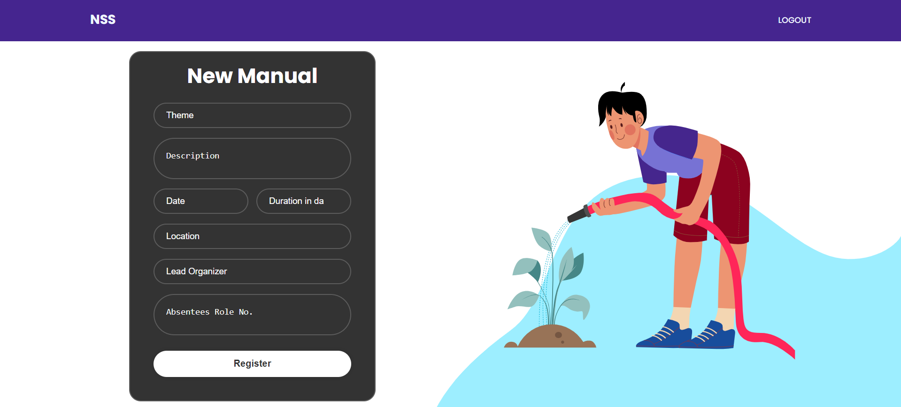

**Admin Login Response:**

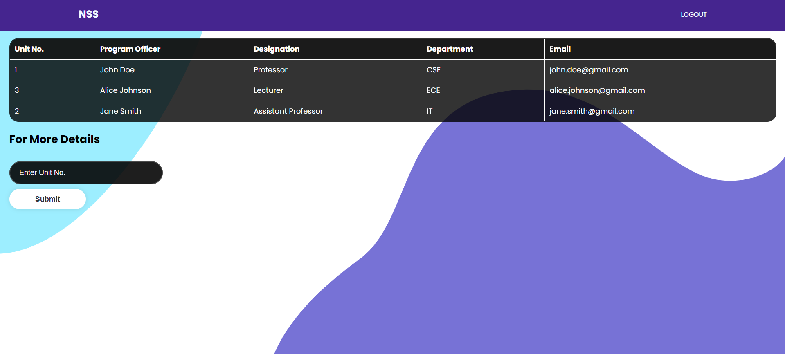

**Update PO:**

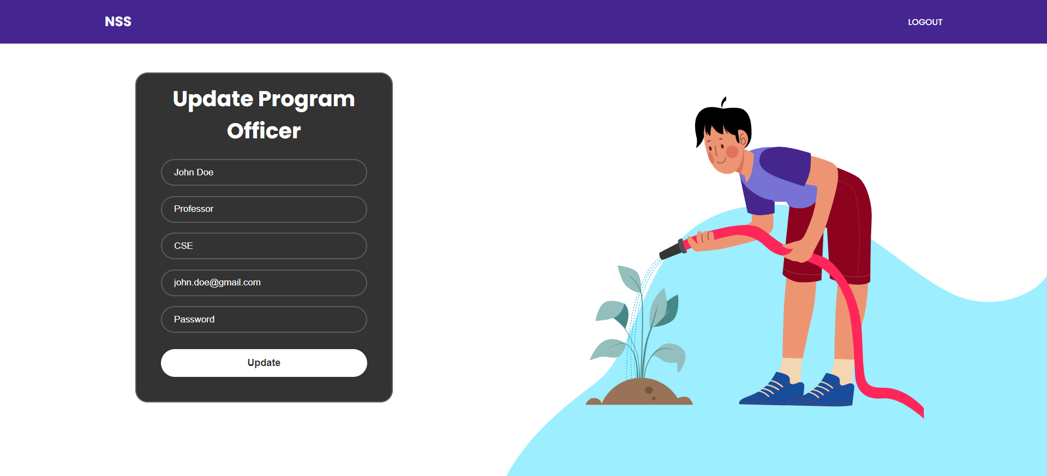

**CONCLUSION:**

In conclusion, the NSS organization database project aims to enhance the overall effectiveness of social service initiatives by NSS units within a college. Future enhancements may include additional features such as Personnel Announcements and Q&A /Feedback Options. It can also be performed on a broad scale by integrating with other colleges which can improve the overall output of NSS initiatives.